DLD LAB 03 SUBMISSION
NAME: YASH RAJ
ROLL NUMBER: 24K-0737

TASK#1:
Expression:
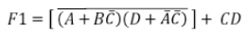

Logic Circuit Diagram:
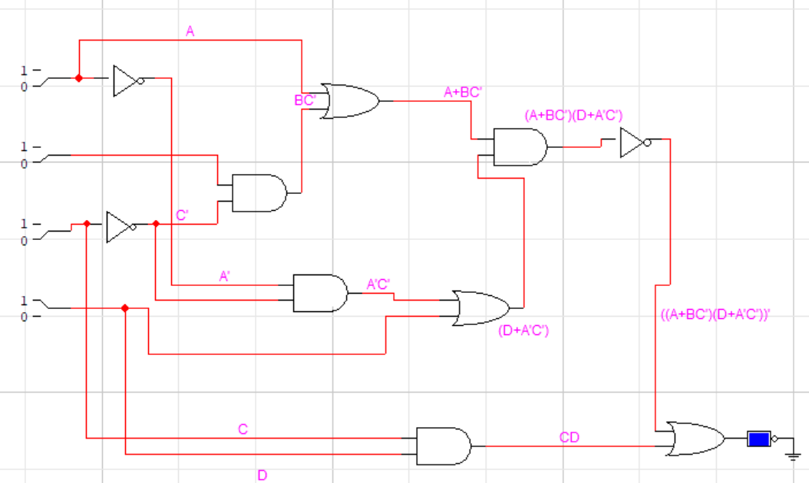

Timing Diagram:
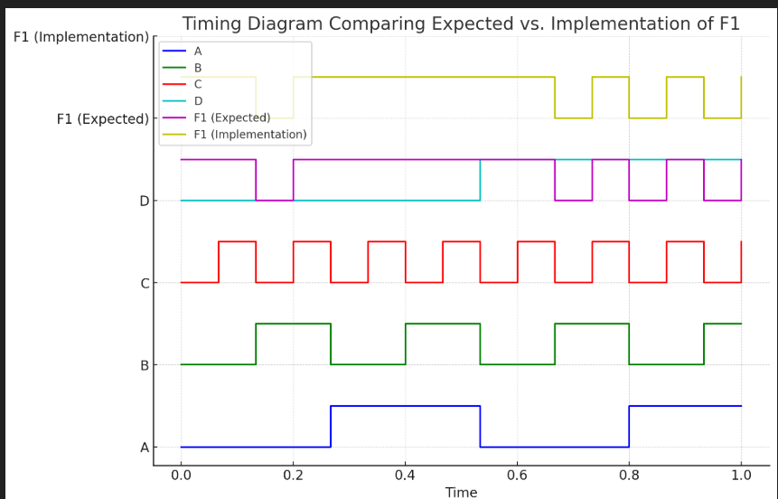

TASK#2:
Expression:
A’B’+AD’+C

Logic Circuit Diagram:
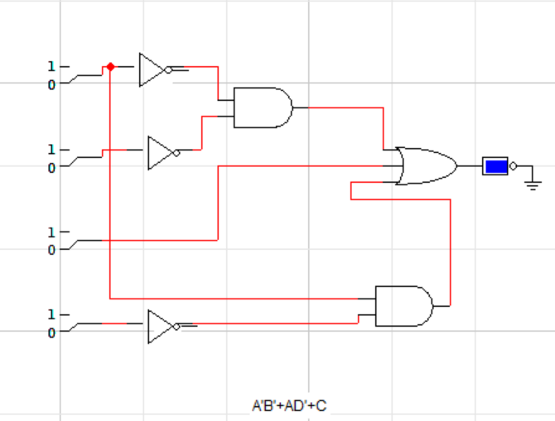

Timing Diagram:
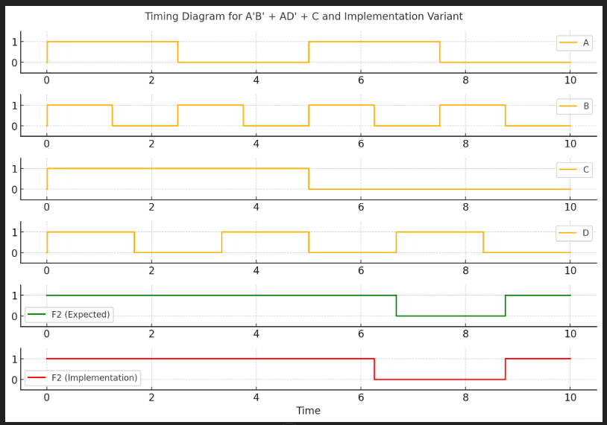

TASK# 3:
Diagram:
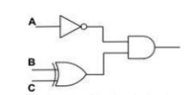
Expression:
A’.(B’C+BC’)
Truth Table:
A | B | C | A' | B' | C' | B'C + BC' | A'(B'C + BC')
0 | 0 | 0 | 1 | 1 | 1 | 1 | 1
0 | 0 | 1 | 1 | 1 | 0 | 1 | 1
0 | 1 | 0 | 1 | 0 | 1 | 1 | 1
0 | 1 | 1 | 1 | 0 | 0 | 0 | 0
1 | 0 | 0 | 0 | 1 | 1 | 1 | 0
1 | 0 | 1 | 0 | 1 | 0 | 1 | 0
1 | 1 | 0 | 0 | 0 | 1 | 1 | 0
1 | 1 | 1 | 0 | 0 | 0 | 0 | 0

Task#4:
Done on logic trainer and also .cct files attached.

Task#5:
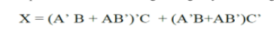
Logic Circuit Diagram:
